# Steering Committee Meeting Summary

|  |  |  |
| --- | --- | --- |
| Date: | March 05, 2020 | |
| Time: | 3:30 – 5:30pm | |
| Location: | Town Hall | |
| Attendees: | In-person:   * Jon Blasco * Dean Fox * Demian Dellinger * Tim Holton * Kathy Behringer * Keith Roberts * Douglass Ball * Brenda Compton   Call-in:   * Charlie Yokley * Tucker McKenzie | Town staff:   * Jeff Triezenberg * John Hodges   Consultant:   * Jay McLeod * Allison Evans * Cindy Szwarckop   Other/general public:   * <none> |
| Materials: | Present for inspection:   1. Zoning Map (current 03/06/2019) 2. Comprehensive Growth Plan Map (adopted 06/12/2018) 3. Flood Insurance Rate Map (adopted 05/02/2006) 4. Summary of Comprehensive Plan recommendations (adopted 06/12/2018)   (Maps and materials are/were also available at: <https://www.garnernc.gov/departments/planning/maps>) | |

## Introduction and Purpose

In late 2019, the Town of Garner contracted with Stewart, Inc.'s Municipal Planning team to undertake an update to the Town's [Unified Development Ordinance (UDO)](https://www.garnernc.gov/departments/planning/development-resources-permitting-information/unified-development-ordinance-udo) which was last comprehensively updated in 2003. The purpose of this update is to help realize the recommendations from the Town’s recently-adopted comprehensive plan update, and other adopted plans, into the land development and land use regulations enforced by the Town. The update will also help simplify, streamline, and clarify the existing regulations, including updating standards as necessary for compliance with state statues and case law and removing obsolete references. As part of the UDO update process, a steering committee was appointed by the Town Council to guide the review and development of recommended changes to the UDO.

## Process

The steering committee will be involved in reviewing public input and adopted plans and providing guidance as these documents are translated into regulations. In addition to the steering committee appointed by Council, a technical working group consisting of Town staff department heads, key staff members, and some outside coordinating agencies (e.g. City of Raleigh Public Utilities Division, etc.) will be consulted for perspective related to process, administration, enforceability, coordination, clarity, and other issues related to each agencies/individual’s professional expertise.

The steering committee will review and comment on each UDO article as it is revised. At regular intervals, these proposed UDO revisions will be made available for review and comment by the public. Regular updates will be made to the Planning Commission and Town Council as well. Prior to any adoption decision by Town Council, the fully-revised UDO will be reviewed by Planning Board for comment and recommendation.

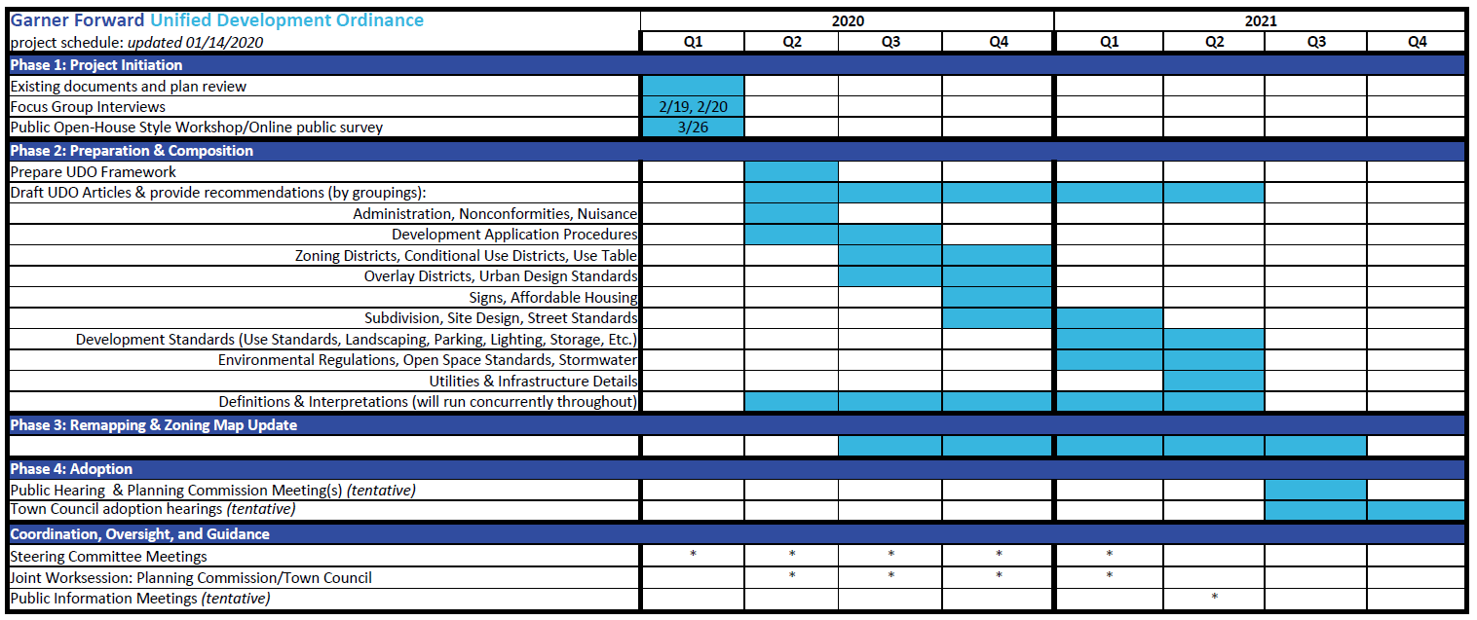

Ultimately, the decision to adopt any changes to the Town’s UDO will be made by Town Council in a public hearing. It is currently anticipated this hearing will occur in the vicinity of October of 2021, although an intermediate adoption of revisions mandated by recent state legislative changes will be required prior to January 2021 – meaning the revisions resulting from the state’s newly created Chapter 160D legislation (see below).

## Chapter 160D

Recently adopted by the state legislature, Chapter 160D consolidates, reorganizes, and streamlines the enabling legislation for land use and development regulation for municipalities and counties. Revisions of ordinances are required prior to January 2021 to bring consistency with this new regulatory structure. In brief summary, Chapter 160D consists of the following:

* Statewide update to enabling legislation (effective 01/01/2021)
  + Consolidate, Organize, & Streamline Development Ordinances
  + Consolidate planning and development regulations as new Chapter 160D
  + Reorganize statutes to be more user-friendly
  + Clarify and modernize provisions
* Requires Uniform Terminology & Procedures
  + Special Use Permit
    - Quasi-judicial approval with site specific conditions
    - Replaces conditional use permit and special exception
  + Conditional Zoning
    - Legislative approval with site-specific conditions
    - Replaces conditional use district
    - Existing conditional use districts transition seamlessly to Conditional Districts
* Simplified Plan Consistency Statements
* Other major UDO-related provisions:
  + Updated comprehensive plan required for zoning enforcement
  + Regulatory maps may be adopted by reference (e.g. floodplain)
  + Form-based code are now *explicitly* authorized
  + Clarifies allowable exactions
  + No third-party rezonings
  + Clarifies procedural approvals and entitlement sunset limitations

## Summaries of input to-date

Brief summaries of guidance from the adopted Comprehensive Plan and stakeholder interviews were presented. For more information, see the appropriate documents or review the copy of the presentation that is posted to the project website (URL address below).

## Upcoming events

A brief description of the process, timeline, and anticipated content to be presented at the first upcoming public meeting was presented. In general the first public meeting will be used to communicate the UDO update process, timeline, and purpose to members of the public, with opportunity for question-and-answer. It will also be used as an opportunity to spread awareness of the update process and upcoming public engagement opportunities.

## Perspective sharing

As a final component of the first steering committee meeting, each attendee was given the opportunity to share what they see as integral to achieving a successful UDO update. Stated alternatively, what needs to occur in this UDO update to move the Town forward into the future with purpose, positive value, and prosperity. The following list briefly summarizes and consolidates the desired priorities that committee members would like to see as outcomes from the UDO update process:

* Communicate to the public that these updates to the UDO will improve the community and enhance the town.
* Beautify the town and enhance “curb appeal”; Create a place that is well-built, attractive, and has quality development that gains value with the passage of time.
* Make the UDO clear, usable, and consistent with other departments, agencies, and regulations.
* Allow market-responsive residential density/intensity.
* Encourage (or at least not impede) the development of workforce housing and regionally-affordable housing opportunities.
* Encourage and support young families.
* Maintain or enhance the school system (to the extent that it is possible in a UDO).
* Balance higher residential densities with quality, usable open spaces, and affordability.
* Acknowledge the existing development stock and pending, currently-approved (future) developments that are already in the pipeline.
* Encourage higher density and intensity development in select areas that are planned for major transit, transportation, or other improvements; Create and enhance the local character in catalyst areas.

Town of Garner’s UDO update project website: <https://www.garnernc.gov/departments/planning/garner-forward/udo-re-write-project>